**Sequence Diagrams:**

**Search Page:**

**Connection Page:**

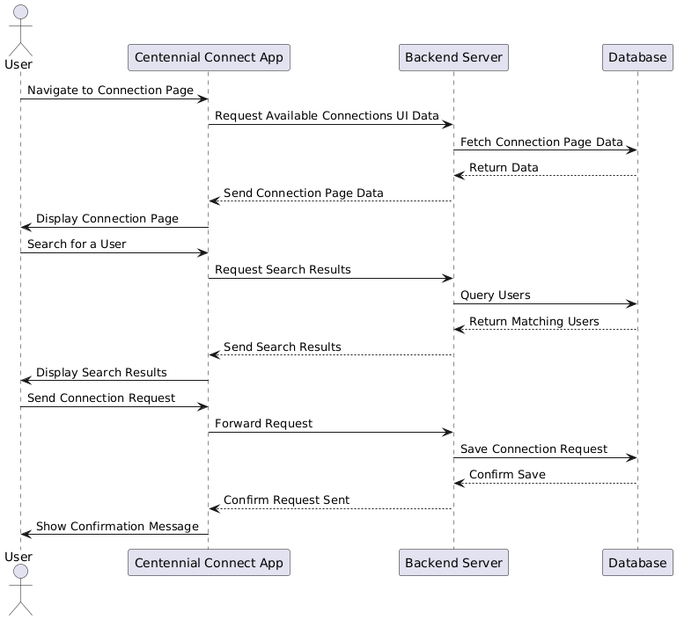

**Connection Database:**

**Event Joining:**

**Functional Requirements (FRs)**

**Search Functionality**

* **FR1:** The system shall allow users to search for events using keywords and filters.
* **FR2:** The system shall display search results based on user queries.
* **FR3:** The system shall fetch event details from the database upon user request.
* **FR4:** The system shall allow users to refine search results using filters.
* **FR5:** The system shall return relevant events based on search queries.

**Connection Functionality**

* **FR6:** The system shall allow users to send connection requests to other users.
* **FR7:** The system shall validate and store connection requests in the database.
* **FR8:** The system shall allow users to accept or reject connection requests.
* **FR9:** The system shall notify users when they receive a new connection request.
* **FR10:** The system shall display a list of confirmed connections to the user.

**Event Joining Functionality**

* **FR11:** The system shall allow users to join an event from the event details page.
* **FR12:** The system shall check event availability before confirming participation.
* **FR13:** The system shall store the user’s event registration in the database.
* **FR14:** The system shall send a confirmation notification upon successful registration.
* **FR15:** The system shall allow users to cancel their event registration if needed.

**Non-Functional Requirements (NFRs)**

**Performance & Reliability**

* **NFR1:** The system should return search results within 2 seconds.
* **NFR2**: The system should handle 500 concurrent users searching for events without performance degradation.
* **NFR3:** The system should support real-time updates for connection requests and event registrations.

**Security & Data Integrity**

* **NFR4:** User data and connection requests should be stored **securely with encryption**.
* **NFR5:** The system should use **HTTPS** to ensure secure communication.
* **NFR6:** The system should implement **access control** to prevent unauthorized event joining.
* **NFR7:** Users should only be able to join an event if they meet the event criteria (e.g., availability, permissions).